  - 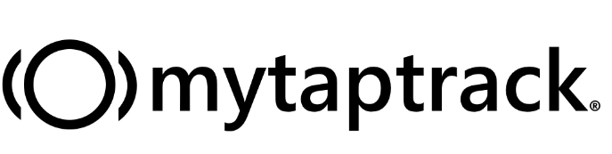
Contact mytaptrack®:
www.mytaptrack.com
info@mytaptrack.com
Follow us on: Facebook, Twitter, Instagram, Pinterest and LinkedIn
@mytaptrack
Mailing address:
PO Box 822 Enumclaw, WA 98022

What is mytaptrack®?
mytaptrack® is a click-touch button and online platform for track the symptoms and behaviors of students with special needs. mytaptrack® is easy to use and gives parents, schools and doctors a smart way to share knowledge in real time.

How does mytaptrack® work?
Each button can be set to record up to three behaviors, allowing you to focus on teaching, not tracking. All data is uploaded to our secure platform, where it can be shared with all members of an IEP team. Schedules can be uploaded into the platform, allowing you to pinpoint exactly when behavior is happening, so you can focus on the why. All information is HIPAA (Health Insurance Portability and Accountability Act) and FERPA (Family Educational Rights and Privacy Act) compliant, so you can rest assured that the data will remain safe.

Why mytaptrack®?
mytaptrack® gives teachers and administrators a way to simplify data reporting for federal, state and local requirements related to IEPs, FBAs, BIPs and 504 plans. When teachers are free to focus on teaching instead of symptoms, it changes everything.

When can we start using mytaptrack®?
You can request a free 3 month trial by emailing info@mytaptrack.com or by visiting www.mytaptrack.com/trial. Each trial comes with two free devices and 3 months of access to the mytaptrack® portal. Each trial also includes training and technical support via Zoom video meeting.

